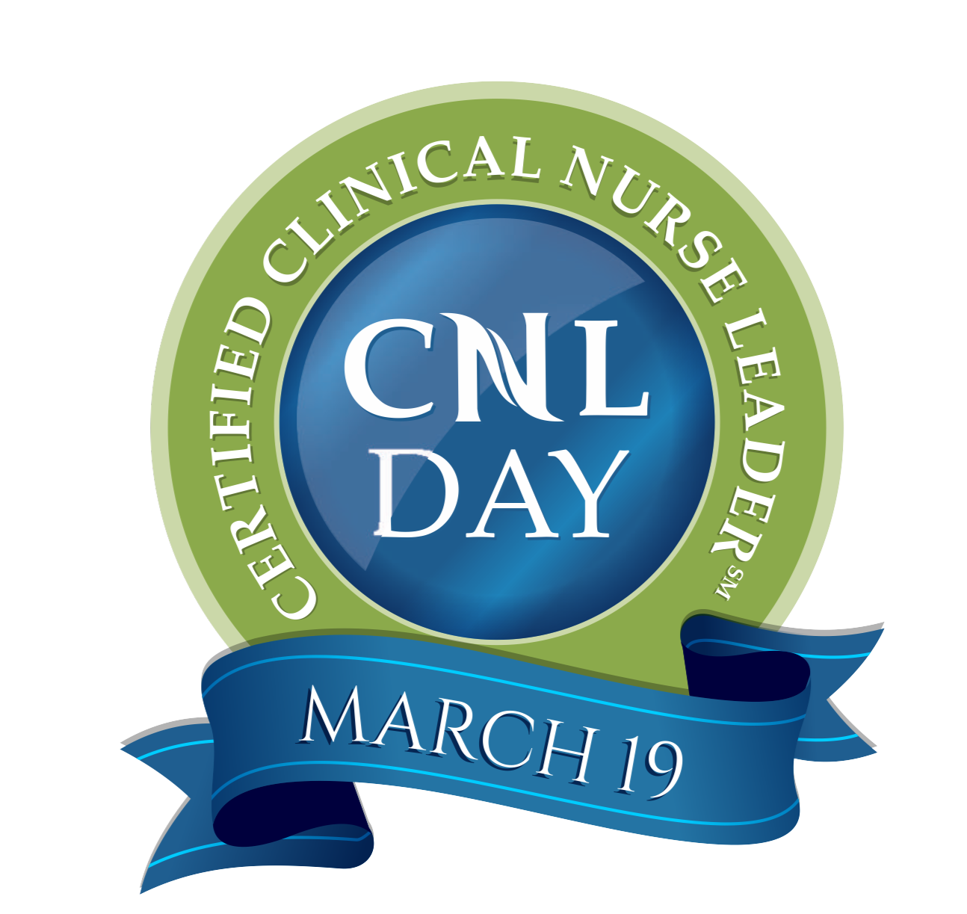

Dear [Name of Certified CNL]:

On behalf of management, staff and patients at [FACILITY], I would like to express our gratitude for the expertise, leadership and professionalism you exhibit as a Certified CNL®. In recognition of your achievements, we celebrate and honor you on this day, March 19, Certified CNL® Day.

As a Certified CNL© you have made a substantial impact on our facility. With your involvement, we have enhanced our healthcare delivery system by:
- Improving patient centered care and patient satisfaction;
- Enhancing critical thinking and innovation by staff;
- Improving unit efficiency;
- Better coordinating care across the healthcare setting in complex situations;
- Increasing safety at the point-of-care (POC); and
- Instituting continuity and consistency at the POC for our physicians and other disciplines.

Further, your leadership has helped us identify improvement opportunities and has improved efficiency by allowing us to target goals, performance measures, and nursing sensitive indicators.

[OPTIONAL ITEMS TO INCLUDE:]

As a token of our appreciation, we have:
- Placed your name on the [facility] honor list, displayed in [location].
- Placed an advertisement in the [name of local newspaper] recognizing you and other Certified CNLs.
- Would like to present you with [gift certificate; chocolate; bonus, specialty certification pin or other significant item] as a token of our recognition of your professionalism and achievements.
- Planned a [luncheon, tea, banquet, office party, or VIP reception] in your honor and in celebration of Certified CNL® Day.

Thank you [NAME of Certified CNL] for your valuable role in improving patient care at [FACILITY]. You have helped us elevate our standards of care and, thereby, bring about better patient outcomes.

With my sincere gratitude,

[CNO or EMPLOYER]

